**Component Name**: Instant Search

**Component Functionality**:

Instant Search app presents an auto suggest kind of component to the user where he/she types some alphabets as search string and the app hits an online API to come up with the suggestions.

On initial load, we are showing all the data. When user selects an option out of the suggestions, the app shows the desired filtered data.

User can select multiple options as well.

We have given option to remove any of the search options as well.

**Usage Areas**:

Can be distributed as shared module for apps needing autosuggest and instant search type of features.

**Component Technical details**:

* Angular cli version 8.3.23
* Typescript version 3.5.3
* rxjs version: 6.4.0
* Angular Material: 8.2.3 – to present rich UI

There are two components in the current app.

One is search-bar.

Other is the home component which is acting as the container to show the filtered data.

There is one data model (data.ts)

There is one data service (data.service) to hit server side API and fetch data.

**How this component can be integrated with other Applications**:

Data needs to be modelled as per the requirement, so data.ts will need to be modified.

Not much changes are required in data.service except the method filterListOptions, that also just for the search data field name e.g. ‘Title’ in the current app.

API URL is stored inside the environment file to make it configurable. This has to be changed with the exact API url.

In search-bar component too, only one modification is needed in the method- filterCategoryList – the search data field name e.g. ‘Title’ in the current app.

Nothing needs to be changed in the home component.

**Screenshots**:

1. **Initial screen**:

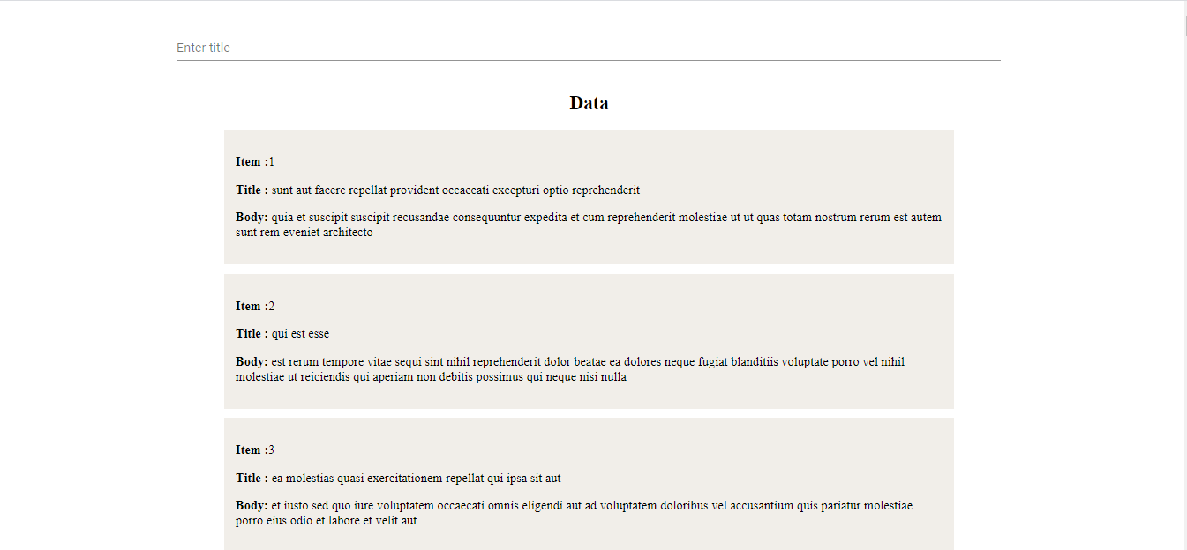

1. **User starts typing the search string, suggestions start populating:**

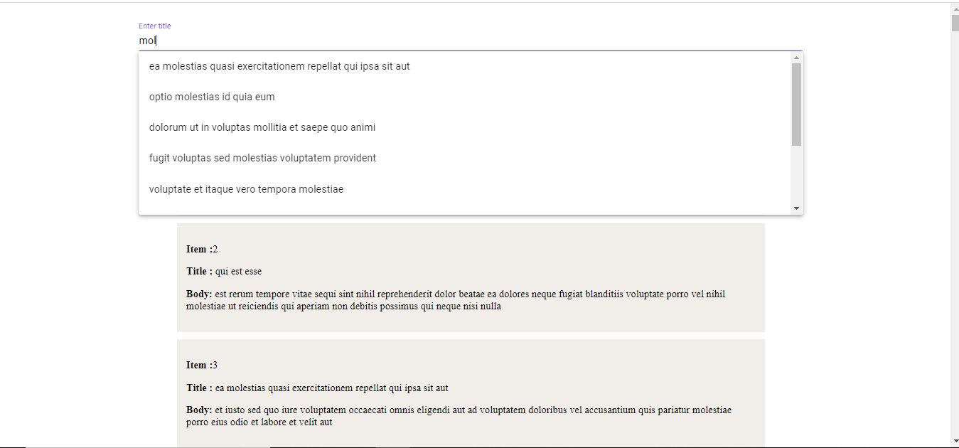

1. **Selection done by the user; data gets filtered accordingly:**

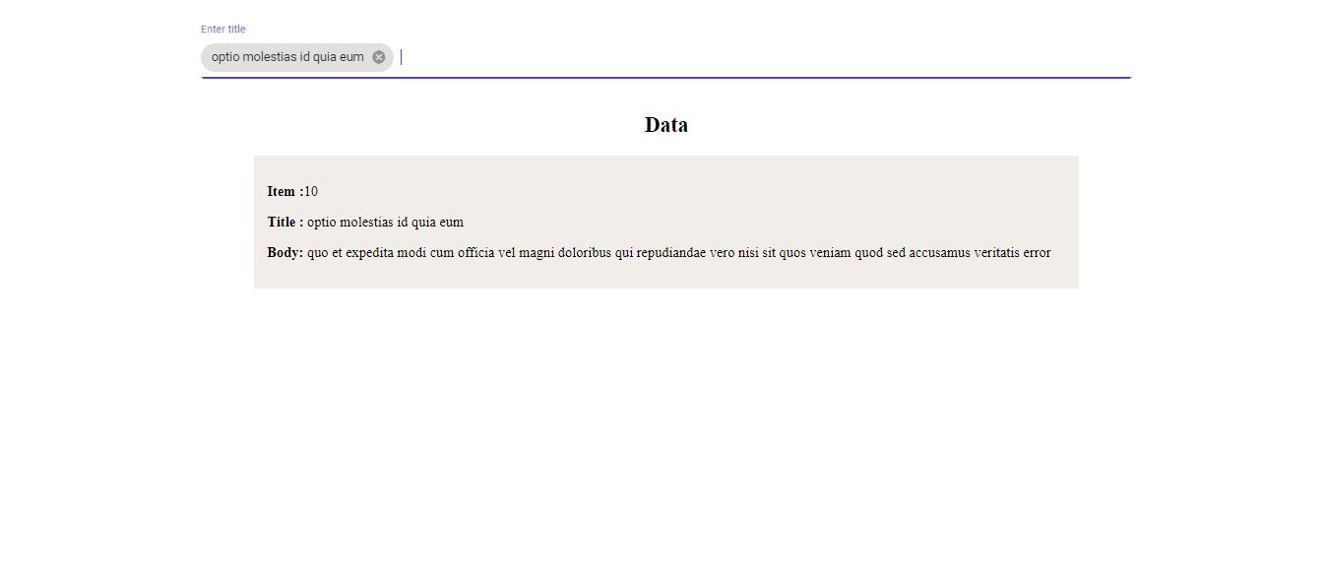

1. **Allows adding multiple search strings:**

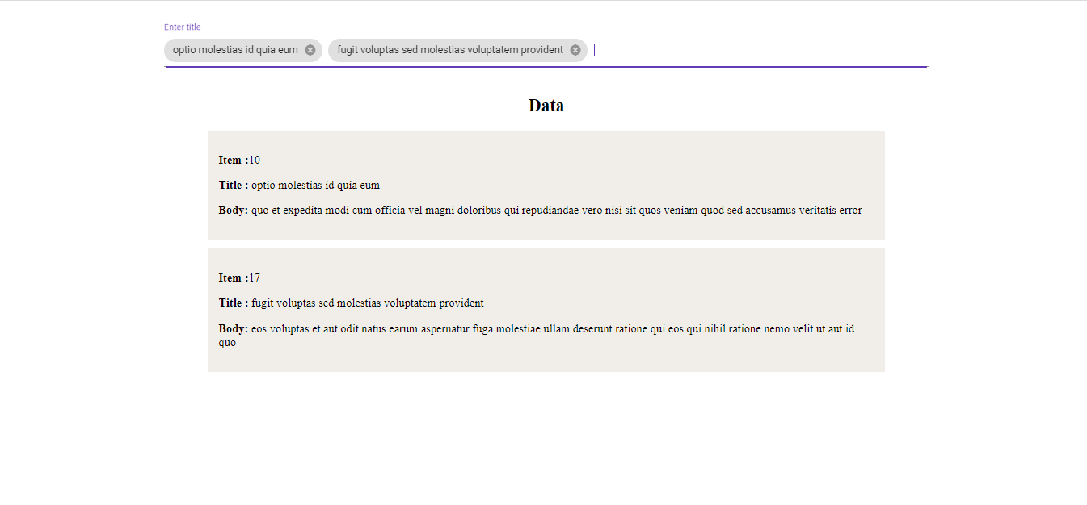

1. **Any of the search string can be removed as well:**

